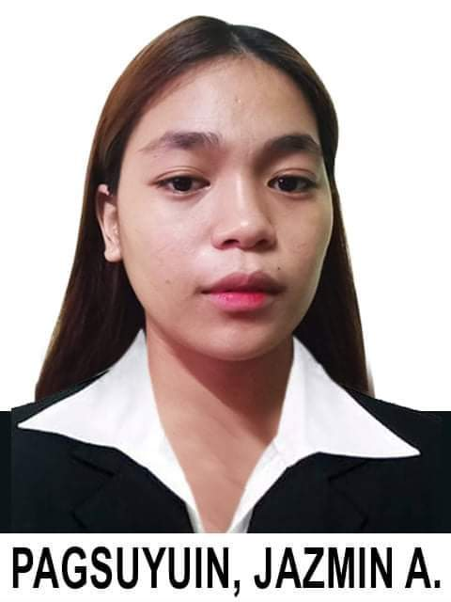
Jazmin A. Pagsuyuin
Ph4 Blk 136 Lt23 Marycris Complex
General Trias, Cavite
Contact no: 09364678132
jhaandres04@gmail.com

OBJECTIVE
To give a good and quality service by sharing my experiences, skills, and abilities and at the same time to have a new experiences that can strengthens my skills, and give me more knowledgefor the growth of my career.

PERSONAL INFORMATION
Date of birth: November 04, 2001
Religion: Catholic
Citizenship: Filipino
Civil Status: Single
Sex: Female
Height: 5'5
Weight: 56 kg
Father's Name: Allan R. Pagsuyuin
Occupation: None
Mother’s Name: Jeanifer Andres
Occupation: Physical Therapist
Language Spoken: Filipino

EDUCATIONAL BACKGROUND

Secondary: Luis Y. Ferrer Jr. North National High School
2014-2018
Philippine Christian University Dasmariñas
2018-2020
Primary: Timoteo Paez Elementary School

Skills and other Qualifications
- Quick learner
- Oriented in detailed
- Had patience and able to stay calm in pressured situation
- Well taught in organizing things

TRAININGS/ SEMINARS ATTENDED

MIHCA Introduction to cruiseline March 4-5, 2019

CONRAD Introduction to Hospitality March 4-5, 2019
MANILA Industry
BAYLEAF HOTEL Hotel Familiariziation w/ Seminars July 3, 2019
and ocular visit
CHARACTER REFERENCES

Mr. Michael T. Enriquez Jr.
SHS FULL TIME FACULTY
PCU - DASMA CAMPUS
09672734728

I hereby certify that the above information is true and correct to the best of my knowledge and beliefs.

JAZMIN A. PAGSUYUIN
Applicant's Signature

