MARIA CAREY L. BAGAIPO
Address: Purok 26 Maa Riverside Davao City.
Email Address: mariacarey1021@gmail.com
Cellphone No: 093-030-77460

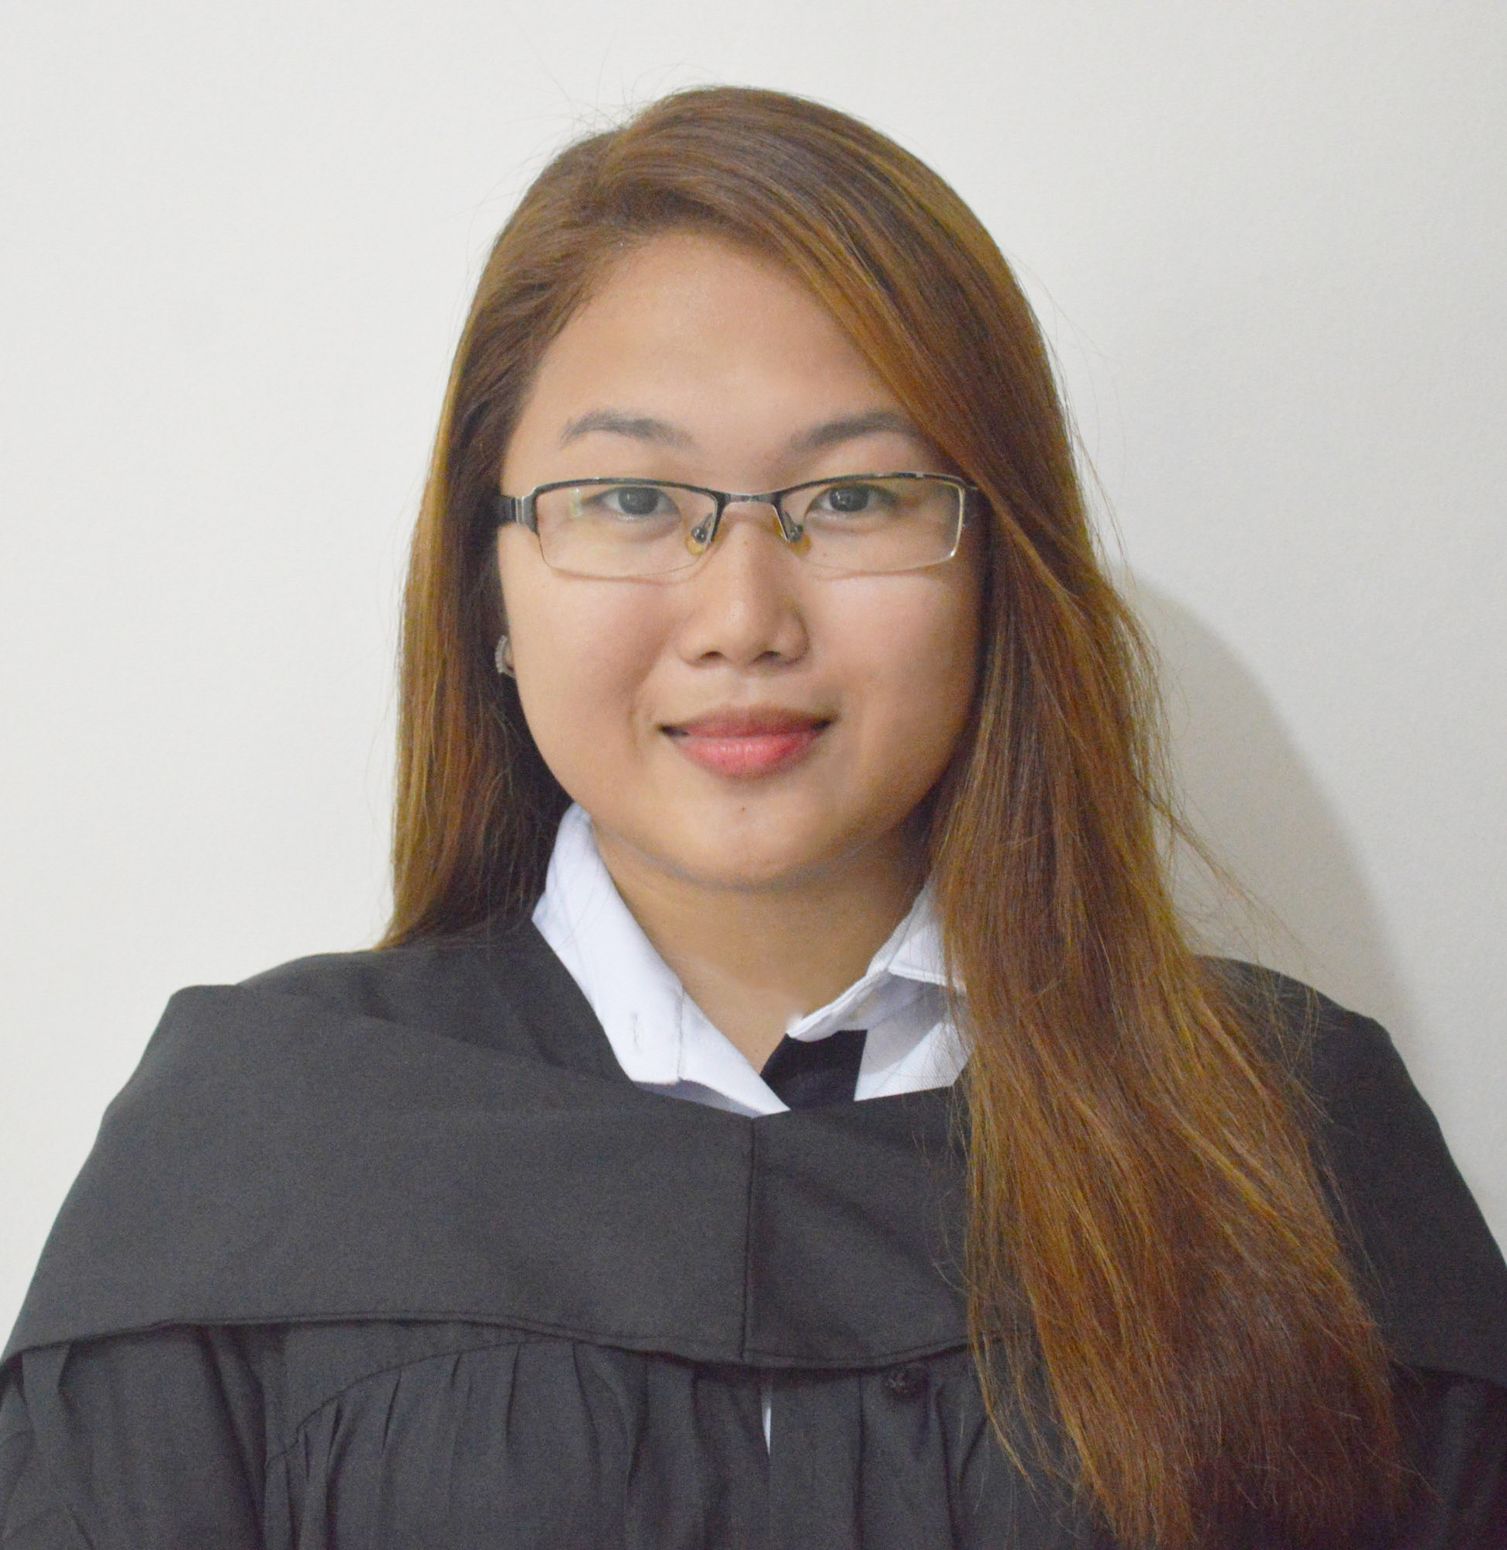
EDUCATIONAL BACKGROUND
Tertiary : AMA Computer Learning Center
2 years Computer Graphics Animation
McArthur Highway, Matina Davao City 2017-2018

Secondary : Davao City National High School
F. Torres St. Davao City 2012-2013

Primary : Maa Central Elementary School
Maa, Davao City 2007-2008
PERSONAL INFORMATION
Age: 21 years old
Date of Birth: June 10,1997
Civil Status: Single
Religion: Catholic
Height :5’0
Weight: 55 klg

EMPLOYMENT HISTORY:
Company: Load Manna
Position: Encoder
Duration: Febuary 11, 2019 - Present
Address: Door 2 Blg. UHSA Ulas Davao City

Company: Lylots Boutique
Position : Office Clerk
Duration : July 24,2018 – November 8,2018
Address : D&D Building Ponciano Reyes St. Davao City

