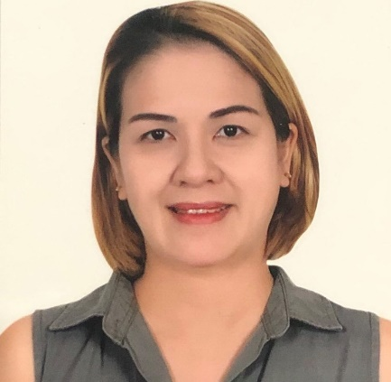  Mayjane Elisa A. Documento  AGE: 43 Years Old  GENDER: Female  ADDRESS:  3 Dapdap Ext. Basak San Nicolas, Cebu City, Philippines, 6000  Contact Information  PHONE:  +63 925 454 5133  EMAIL:  mj.amadora@yahoo.com  HOBBIES:  Baking  Cooking  Dancing  Making Friends  Surfing the Net |  | EDUCATION  University of San Carlos  June 1994 – March 1999  Bachelor of Science in Business Administration  INS Human Resource Development Corporation  August 2003 – February 2004  Orientation – Seminar on Foundation of Spiritual Care for the Elderly  Sunshine Center (School for Special Children)  February 23 – 27, 2004  Observation and Training for the Care of Special Children  Christ for Asia Association, Inc.  March 1 – 5, 2004  Childcare Giving and Housekeeping  Ramon Durano Foundation, Inc.  March 8 – 12, 2004  Skills Training for the Elderly  WORK EXPERIENCE  Philippine Amusement and Gaming Corporation (PAGCOR) [Bingo Teller and Verifier]  February 2001– February 2002  - Responsible for collecting cash from customers or credit card charge transaction and balancing cash on hand to verify the funds received  - Requesting monthly replenishment of petty cash fund  - Checking the validity and correctness of winning tabs  - Ensuring that the cash is accurate for remittance  Sarossa International Hotel and Residential Suites [Front Office Staff]  March 2006 – December 2006  - Customer Service  - Receiving calls and inquiries for bookings and reservation  - Receiving calls and transferring calls to respective office personnel  - Responsible for incoming and outgoing taxes  - Sending acknowledgement receipts, policies, and other documents by post  - Encoding weekly sales and itinerary reports  - Preparing daily attendance sheets  - Maintaining office files  First Gulf Bank [Direct Sales Executive]  February 2008 – March 2009  - Planning and executing promotions and marketing activities to promote sales  - Following up customer leads in a timely manner  using appropriate communication channel  - Handling inquiries and making follow ups on credit card application  - Building a strong client base to contribute to the on-growing growth of the bank and its profile and achieving goals
Pizza Pedrico’s Food Corporation [Business Franchise Owner]
October 2010 – July 2020
- Responsible for the growth, stability, and direction of the business
- Facilitating the daily activities of the business
- Facilitating the sales protocol as well as the deliveries
- Handling the payroll

Amadora’s Medical Clinic [Medical Office Assistant]
2018 – Present
- Checking the temperature of the patient
- Taking medical histories
- Recording vital signs
- Explaining treatment procedures to patients
- Preparing patients for examination
- Assisting the physician during the examination
- Updating patients record

