Nelson B. Agulay
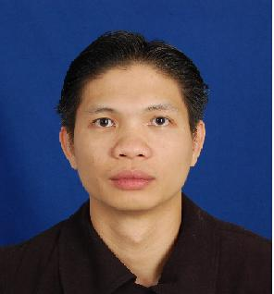
Nasser Al-Bader Street 4
Block 12 Salmiya Kuwait
alyssaamarah23@gmail.com
Contact No.: +965 66859464

OBJECTIVE
To occupy a position of responsibility, progressive and dynamic in nature, which further develops interpersonal skills in the performance of operations, related activities.

WORKING EXPERIENCE

Apparel Group Trading Company Tommy Hilfiger (Marina Mall Kuwait)
Sales Associate
September 08, 2016 - Up to Date

- Smile and Greet the Customers.
- Acknowledge them by using a friendly greetings and a warm or genuine smile.
- Identifying customer needs by asking them what’s the product they need or want to buy or what they are looking for.
- Presenting products is product knowledge such as for us to know what’s the product that we are going to sell and introduce it to the customer.
- Encourage to try on the item for them to know if it fits to them or for them to be satisfied.
- Up selling or suggestive selling this is where we are going to introduce to the customers the promotional and sale items.
- Deliver excellent customer service that ensures ongoing sale and high levels of customer satisfaction.
- Work with customers to determine their needs and then recommend the right product to solve the customer’s problem.
- Assist in ensuring that the product presentation area is clean and organized.
- Develop and cultivate strong buying relationships with customers.
- Use company literature and available training resources to stay up to date on product features.

Alghunaim Trading Company Coffee Bean And Tea Leaf (Kuwait - Salmiya)
Lead Barista
May 10, 2013 – July 12, 2016

Jawad Business Group Costa Coffee (Saudi Arabia - Riyadh)
Senior Barista
October 8, 2009 – August 20, 2012

AMERICANA KFC Qurain (Kuwait)
(Kuwait Food Company) Service Crew
February 9, 2007 – March 27, 2009

SKILLS

- Computer Technician Literate.
- Can assemble computer.
- Willing to be trained.
- Easy to learn new things.

PERSONAL BACKGROUND

AGE: 38 Years Old
DATE OF BIRTH: January 18, 1982
HEIGHT: 5’9” ft.
CIVIL STATUS: Married
CITIZENSHIP: Filipino
RELIGION: Roman Catholic

EDUCATIONAL ATTAINMENT

College: Quezon City Polytechnic University
Computer Engineering Technology
2003 – 2004

CHARACTER REFERENCE

Ryan Austria Ms. Charmie Bernadas
Area Coordinator Store Manager
Coffee Bean and Tea Leaf Kuwait Tommy Hilfiger
+965 69950330 22597845

I hereby certify that the above information’s given are true and correct upon my knowledge.

___________________________
NELSON B. AGULAY

