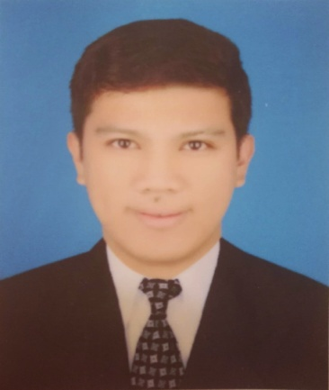

MARK ANTHONY U. SALDO
B.S. Hotel and Restaurant Management
Unit 7 Floor No. 4 Building 64, St. 211
Block 2, Mahboula, Kuwait City
Cell phone No. +965 600 60 581
Email add: mhackysaldo@gmail.com

OBJECTIVES
To be a part of an organization that offers superb opportunities for career progression and inspiring working environment. An organization where I can add value and share my knowledge/experiences from the Food & Beverages and Customer Service Industry by using my excellent skills and to create positive customer experiences which in return will generate more income and savings for the company.

SUMMARY
- 9 years experienced in hospitality industry.
- Trained to provide customer service and establishing rapport to the guest.
- Working knowledge in the Hospitality industry by providing Customer service and Food & Beverage position.
- Ability to perform job functions with attention to detail, speed, and accuracy and follows direction thoroughly.
- Hardworking, self-motivated individual with proven record of responsibility and time management skills.
- Ability to win the heart of guest.

PROFESSIONAL EXPERIENCE

Dining Supervisor
October 2018 - present
Carinos, Italian Grill, Kuwait
- Take full responsibility for running restaurant in the absence of the Restaurant Manager.
- Ensuring service excellence at all times performed in a professional manner and to the style as specified by the company.
- Assist the Restaurant Manager in disciplinary matters, keeping the staff well informed of the restaurant objectives and standards.
- Make sure that the company policy and vision are followed at all times.
- Administered all work according to service standards and trained staff on same.
- Organized work to ensure optimal level of guest satisfaction.
- Manage all paperwork and cash duties.
- Ensured sanitary standards.

FOH Trainer ( Host & Server )
October 2012 -October 2018
Carinos Italian Grill, Kuwait
- Organized and supervised server / host duties throughout shifts as well as ensure that all tasks were completed thoroughly prior to shift’s end.
- Train new staff on guest service expectations, safety procedures, proper food handling and restaurant standard.
- Monitor dining to ensure optimal guest experiences.
- And set an example for co-workers by effective serving guest in a friendly manner.
- Work with individual server to improve performance.
- Attended trainer meetings with General Manager to review issues of the restaurant.

Host
October 2010 – October 2012
Carinos Italian Grill, Kuwait
- Greet and acknowledge guests and seat patrons by escorting them to assigned table, or communicate delays and offer additional services such as beverages to keep them occupied while waiting.
- Present menus, create personal dining experience, answer questions, and offer information on menu items, beverages, and specials.
- Accept and organize reservations, and prioritize reservations to accommodate guest..
- Prepare seating assignments prior to service and present plan to restaurant during pre-shift meeting.
- Walk through dining room during service to ensure guest satisfaction and advise servers and bussing staff of specific service needs.
- Addressed guest requests or complaints, and escalated major complaints to manager.

Reservation Officer
March 2009 – February 2010
The Travel Guru Inc.
Ortigas Center, Pasig City, Philippines
- Provide customers with standard of quality service at all times, and accurate information on quotation/availability/facilities as required by the clients.
- Maintain good relation with customers, corporate accounts and suppliers: Airlines/hotel/car rental/tour operators at all times.
- Secure updated rates of suppliers

CERTIFICATE OF ACHIEVEMENT

Carino’s Italian Grill
- Certified Host / Server Trainer
- Employee of the Year 2015

EDUCATION

Bachelor of Science in Hotel and Restaurant Management
Lyceum of the Philippines University, Intramuros, Manila, 2007

Associate in Hotel and Restaurant Management
Pamantasan ng Lungsod ng Pasay , Pasadeña Street F.B. Harrison, Pasay City, 2004

TRAINING ATTENDED

- 7 habit of Highly Effective People Workshop
Carino’s Italian Grill, Kuwait

- Amadeus Corporate University
LKG Building Ayala Avenue , Makati City, Philippines
July 6-9, 2009

PERSONAL INFORMATION

Age : 34 years old
Height : 5`11”
Weight : 140 lbs
Civil Status : Single
Citizenship : Filipino
Religion : Catholic

REFERENCE:
Available upon request.

