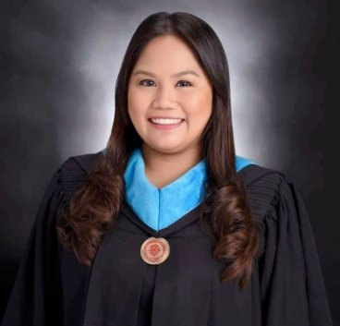
CLAIRE G. ASAGRA
1718 DPWH 2nd St. Brgy. 905 Punta Sta.Ana Manila
09491209192
claireasagra06@gmail.com

OBJECTIVES
- To develop professional skills of teaching students of every age by providing work-based learning.
- To offer quality education to students.

PERSONAL INFORMATION

Date of Birth : September 14, 1993
Place of Birth : Manila
Age : 25
Civil Status : Single
Weight : 60kg
Height : 5’4
Citizenship : Filipino
Religion : Catholic
Language Spoken : Filipino and English
Mother Maiden Name : Delia Gernale Asagra
Father Name : Dante Javier Asagra

EDUCATIONAL BACKGROUND

Tertiary : Eulogio “Amang” Rodriguez Institute of Science and Technology
Bachelor of Secondary Education major in TLE
2015 – 2019

Secondary : Mandaluyong High School
Aglipay Street Mandaluyong City
2007-2011

Primary : San Gabriel I Elementary School
General Mariano Alvarez Cavite City
2001– 2007

ACHIEVEMENT

NCII : TESDA DOMRAC Refrigiration And Airconditioning
Mandaluyong City

Cum Laude : Eulogio “Amang” Rodriguez Institute of Science and Technology
Bachelor of Secondary Education major in TLE
2015 – 2019

SKILLS/QUALIFICATIONS

- Multi-tasking
- Time Management
- Ability to work under pressure
- Computer literacy
- Leadership
- Hardworking and Industrious

WORK EXPERIENCE

Company : Mc Donalds Philippines Golden Arches
Position : Service Crew
Area : NCR
Year : 2013-2015

Company : Our Lady Of Fatima Parochial Educational Center
Position : Computer/Technology and Livelihood Education Teacher
Area : NCR
Year : 2019-2020

CHARACTER REFERENCE

Name : Nicaseo Bravo
Position : Teacher I
Number : 09321192407

I hereby certify that the above information is true and correct to the best of my knowledge and belief.

Claire G. Asagra
Applicant

